Testing Plan
Week 2: Prototype testing of Hacker House Version 1:
Testing Questions | Yes/No | Notes/Evidence
Does the prototype open or start correctly? | Yes | 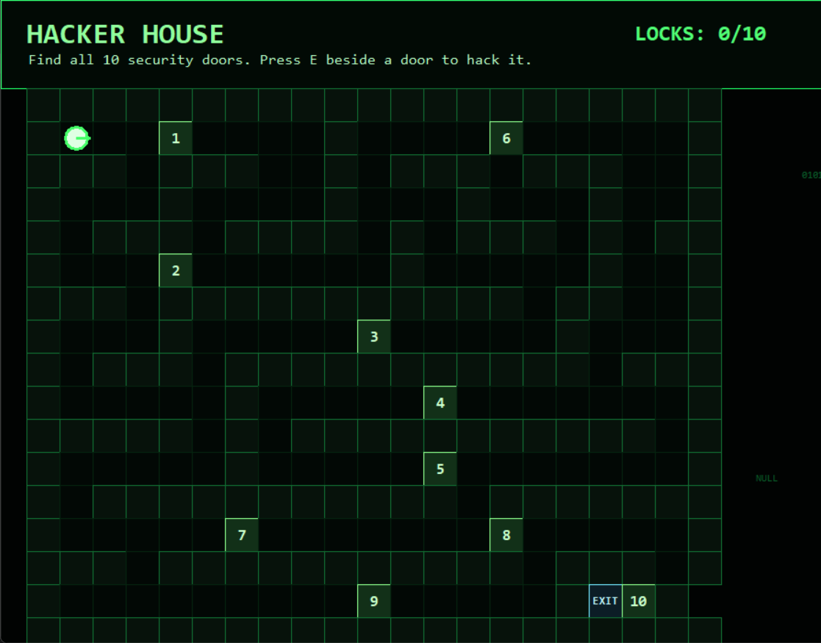
Is the welcome screen clear? | No | Not yet added
Are the instructions clear? | Yes | 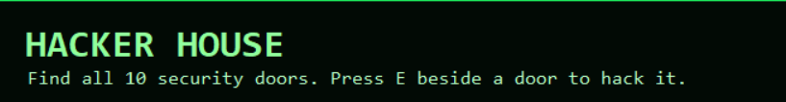
Is the first challenge working? | Yes | 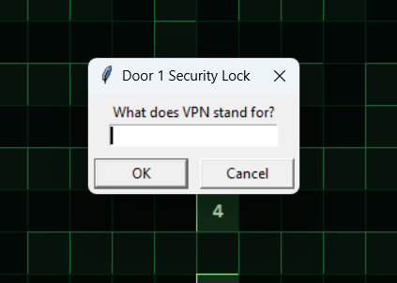 (Filler Question)
Does the correct answer show correct feedback? | Yes/No | The door does open and you get a ring when its correct but no other indication are shown  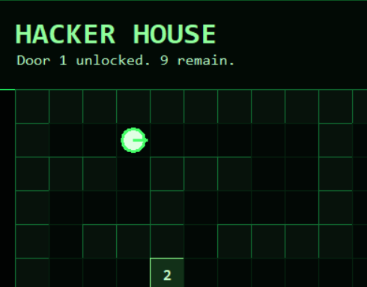
Does the wrong answer show helpful feedback? | No | Feature needs to be added
What needs to be improve? |  | Map bugs, Visual Improvement
Testing Outcome: What worked well?
The game ran mostly smoothly and it looks visually appealing. The gameplay is also simple and gameplay instruction has been shown on the top of the screen with clear indication of the goal and how many doors need to be unlocked.
Testing Outcome: What did not work well?
The map needs to be improved as the player can’t complete the game as the Door no.10 is blocked by exit and you can’t go through the exit without unlocking all the doors.
Improvements to Prototype v2?
- Map improvement
- Hints and feedback need to be added
- Reward system hasn’t been implemented
- No mainmenu
- Actual questions need to be added instead of filler ones

